IT DEPARTMENT WEBSITE
A Project Report
In partial fulfilment for the award of
DIPLOMA IN INFORMATION TECHNOLOGY


Submitted By :
Rajesh Kulkarni FE23IF003
Yashraj Deshmukh FS23IF036
Utkarsh Gade FS23IF036

Under the guidance of Prof. Namrata Wankhade

Department of Information Technology Government Polytechnic Mumbai

GOVERNMENT POLYTECHNIC MUMBAI DEPARTMENT OF INFORMATION TECHNOLOGY

CERTIFICATE

This is to certify that the project report entitled, “DAILYDONE” is the Bonafide work of “Rajesh Balaji Kulkarni (FE23IF003), Yashraj Abhijjet Deshmukh (FS23IF023), Utkarsh Umesh Gade (FS23IF036)” submitted in partial fulfilment of the requirements for the award of Diploma in Information Technology of Government Polytechnic Mumbai.

Dr. Sachin Bharatkar Ms. Namrata Wankhade

HEAD OF THE DEPARTMENT PROJECT GUIDE

Dr. Nitiket N. Mhala.
PRINCIPAL EXTERNAL EXAMINER

DECLARATION

We hereby declare that the project entitled “IT Department Website” is being submitted by us towards the partial fulfilment of the requirement for the award of Diploma in Information Technology is a project work carried by us under the supervision of Prof. Dipali Gosavi and have not been submitted anywhere else.

We are solely responsible if any kind of plagiarism is found in our report.

Date:

Name of students Enrollment No. Signature
- Rajesh Kulkarni FE23IF003
- Yashraj Deshmukh FS23IF023
- Utkarsh Gade FS23IF036

ACKNOWLEDGEMENT

We take this opportunity to express our deep gratitude to all those who have helped us in completing our project successfully.
We would like to extend our sincere thanks to Prof. Dipali Gosavi & Prof. Namrata Wankhade our project guide, for her continuous support, valuable guidance, and constant encouragement throughout this project work.
We are also thankful to Dr. SACHIN BHARATKAR SIR, Head of the Information Technology Department, for providing us with the necessary facilities and an environment conducive to research and development.
Our special thanks to Dr. Nitiket N. Mhala, Principal, Government Polytechnic Mumbai, for his constant inspiration and motivation.
Lastly, we extend heartfelt thanks to all faculty members and friends for their cooperation and support throughout this project.

Rajesh Kulkarni (FE23IF003)
Yashraj Deshmukh (FS23IF023)
Utkarsh Gade (FS23IF036)

PROJECT OVERVIEW

The project “DailyDone” is a community-driven platform designed to connect people who need help with everyday errands to nearby helpers who are willing to assist. The system bridges the gap between those seeking assistance and those looking for flexible earning opportunities, fostering collaboration, trust, and community spirit. project “DailyDone” is a community-driven platform designed to connect people who need help with everyday errands to nearby helpers who are willing to assist. The system bridges the gap between those seeking assistance and those looking for flexible earning opportunities, fostering collaboration, trust, and community spirit.

In today’s fast-paced lifestyle, many individuals face challenges in managing simple but time-consuming tasks such as grocery shopping, deliveries, or household errands. DailyDone provides a reliable digital solution where users can post their tasks and get matched with verified helpers in their locality. Through this, it not only simplifies daily life but also encourages local engagement and mutual support.
The platform is built using a modern full-stack architecture — the frontend is developed in React (with Vite) and styled with Tailwind CSS for a clean, responsive, and visually engaging experience. The backend is powered by Spring Boot, ensuring robust performance, scalability, and secure API communication, while PostgreSQL efficiently manages user data and transactions.

DailyDone goes beyond just being a service app; it’s a digital ecosystem that promotes neighborhood collaboration. By focusing on transparency, reliability, and convenience, the platform transforms how people connect, help, and support each other in their communities — making daily life truly easier, safer, and done.
INDEX

Sr no. | Topic | Page no.
1 | Chapter 1: Introduction  - Introduction  - Background  - Objective  - Scope and Purpose  - Scope  - purpose
2 | Chapter 2: System Analysis  - Existing System  - Requirement Analysis  - Hardware Requirements  - Software Requirements  - Literature Survey
3 | Chapter3: Planning Phase  - Feasibility Study  - Software Model  - Flow of System  - System Design
4 | Chapter 4: Testing  - Testing Approach  - Unit Testing  - Integration Testing  - System Testing
5 | Chapter 5: Conclusion and References  - Appendices  - References  - Conclusion and Future Work

Chapter 1: Information

1.1 Introduction

- DailyDone is a digital platform designed to simplify everyday life by connecting people who need help with daily tasks to trusted helpers in their neighbourhood. Whether it’s picking up groceries, running errands, or handling small household activities, DailyDone allows users to post their tasks and get assistance quickly and securely.

- The platform brings together individuals who are seeking help and those who are ready to offer it, fostering a sense of trust, collaboration, and community engagement. Through this approach, DailyDone aims to make neighbourhood support accessible, organized, and mutually beneficial.

- DailyDone not only focuses on simplifying daily errands but also emphasizes trust and safety through a verified user system and transparent reviews. Every interaction is designed to ensure reliability and build confidence between helpers and users, making the platform dependable for real-world community assistance.

- Built with a modern and responsive user interface, DailyDone ensures an intuitive experience for both task posters and helpers. The integration of real-time updates, notifications, and secure authentication creates a smooth, reliable, and user-centric environment.

1.2 Core Functionalities

    - User Registration and Authentication:
Users can sign up using their valid email ID or mobile number. Each user has to log in before accessing features like posting or accepting errands, ensuring verified and secure participation.

    - Post an Errand:
Users who need assistance can create a new errand post by specifying the task details, location, and expected time. This makes it easy for nearby helpers to view and respond to the request.

    - Accept and Complete Tasks:
Helpers can browse the list of available errands in their area, accept suitable ones, and complete them within the given time. Once done, users can confirm.

    - Real-Time Communication:
A built-in messaging and notification system allows users and helpers to coordinate efficiently, ensuring clear communication during the task.

    - Ratings and Reviews:
After completing a task, both the user and the helper can give feedback through ratings and short reviews. This feature helps maintain trust and transparency in the community.

    - Community Support and Safety:
DailyDone focuses on local trust and real connections. By promoting verified users, fair interactions, and community-driven engagement, it strengthens cooperation among neighbors.
  - Objective

The main objective of DailyDone is to create a smart, simple, and community-driven web platform that connects people who need help with daily errands to those who are ready to assist. The system focuses on trust, independence, and reliability to make daily task management smoother and more accessible for everyone.
The specific objectives of this project are as follows:

- To connect people efficiently:
Build a platform where users can quickly find reliable helpers nearby for everyday errands such as deliveries, pickups, or small household tasks.

- To provide dual-role functionality:
Allow users to act either as a Task Poster (User) or a Helper within the same system, making it flexible and useful for all types of users.

- To make task handling simple and transparent:
Provide clear task status tracking such as Incomplete, Ongoing, and Completed for both users and helpers to ensure smooth workflow.

- To promote community support:
Strengthen neighbourhood cooperation by encouraging people to help each other through an organized and trustworthy digital platform.

- To ensure accessibility and convenience:
Offer a user-friendly interface that works on any device, with a simple cash or UPI-based payment method to keep the process fast and straightforward.

- To minimize dependency on traditional services:
Replace time-consuming manual communication with an instant, digital solution that connects helpers and users in real time.

- To maintain independence and fairness:
Unlike corporate platforms such as Zomato, Uber, or Urban Company, DailyDone is not controlled by any centralized authority or company. Users and helpers interact freely and directly, ensuring equal opportunities, transparent communication, and fair collaboration without platform commissions or restrictions.

  - Scope and Purpose

- Purpose:
The purpose of this project is to provide a practical, people-powered alternative to modern service platforms that are often corporate-driven. DailyDone allows people to help one another without depending on large companies or fixed pricing systems, giving users complete freedom to communicate, negotiate, and cooperate directly.

This platform is built to encourage local collaboration, convenience, and self-reliance by making small everyday help accessible at the neighborhood level. By using simple features like cash or UPI-based payments, verified users, and a responsive interface, DailyDone aims to make technology serve the people — not control them.
- Scope:
The scope of the project DailyDone covers the development of a community-based web platform that enables users to post and accept everyday errands within their local area. The system provides complete functionality from user registration to task completion, focusing on simplicity, trust, and direct communication between participants.

The platform operates entirely through a web interface accessible via dailydone.in, making it easy for anyone with internet access to use. Both users and helpers can manage their activities through personalized dashboards — users can post tasks, while helpers can browse and accept them. The project scope also includes profile management, real-time task status updates, and clear categorization of errands into Incomplete, Ongoing, and Completed.

The system’s design ensures that all control stays with the users, without interference from third-party organizations or automated restrictions. It focuses on creating a decentralized and fair environment where individuals connect directly for mutual benefit.

Chapter 2:

System Analysis

In the current scenario, there is no structured or community-based platform for people who need help with small everyday errands such as delivering groceries, collecting parcels, or assisting elderly neighbors.

Chapter3

Planning Phase

Feasibility Study

After doing the project ‘IT Department Website’, study and analysing all the existing or required functionalities of the system, the next task is to do the feasibility study for the project. All projects are feasible – given unlimited resources and infinite time.
Feasibility study includes consideration of all the possible ways to provide a solution to the given problem. The proposed solution should satisfy all the user requirements and should be flexible enough so that future changes can be easily done based on the future upcoming requirements.Feasibility study is used to check the visibility of the project under the consideration of the theoretical project and its various types of feasibility are conducted below are important which are represented are as follows: -

Technical feasibility: -

Technical Feasibility determines whether the work for the project can be done with the existing equipment’s software technology and available personals technical feasibility is concerned with the specified equipment and software that will satisfy the user requirement this project is feasible on technical remark also as the proposed system is
beneficiary in term of having a soundproof system with new technical equipment’s install on the system that proposed system can run on any machine supporting window and work on the best software and hardware that had been used while designing the system so it would be visible in all technical term of feasibility.
This included the study of function, performance and constraints that may affect the ability to achieve an acceptable system. For this feasibility study, we studied complete functionality to be provided in the system, as described in the System Requirement Specification (SRS), and checked if everything was possible using different type of frontend and backend platforms.

Operation feasibility: -

No doubt the proposed system is fully GUI based that is very user friendly and all inputs to be taken all self-explanatory even to a layman. Besides, a proper training has been conducted to let know the essence of the system to the users so that they feel comfortable with new system. As has our study is concerned the clients are comfortable and happy as the system has cut their loads and doing.

2.2 Software Model

SDLC Software Development Life Cycle

Software Development Life Cycle (SDLC) is a process used by the software industry to design, develop and test high quality software. The SDLC aims to produce a high-quality software that meets or exceeds customer expectations, reaches completion within times and cost estimates.

- SDLC is the acronym of Software Development Life Cycle.

- It is also called as Software Development Process.
- SDLC is a framework defining tasks performed at each step in the software development process.
- ISO/IEC 12207 is an international standard for software life-cycle processes. It aims to be the standard that defines all the tasks required for developing and maintaining software.

SDLC is a process followed for a software project, within a software organization. It consists of a detailed plan describing how to develop, maintain, replace and alter or enhance specific software. The life cycle defines a methodology for improving the quality of software and the overall development process.

The following figure is a graphical representation of the various stages of a typical SDLC:

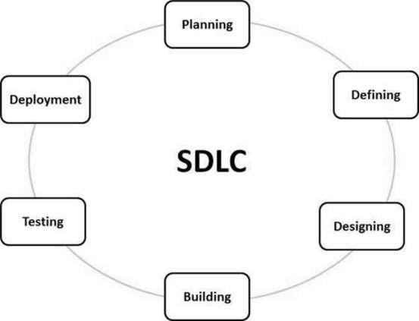

A typical Software Development Life Cycle consists of the following stages –

- Stage 1: Planning and Requirement Analysis
Requirement analysis is the most important and fundamental stage in SDLC. It is performed by the senior members of the team with inputs from the customer, the sales department, market surveys and domain experts in the industry. This information is then used to plan the basic project approach and to conduct product feasibility study in the economical, operational and technical areas.
Planning for the quality assurance requirements and identification of the risks associated with the project is also done in the planning stage. The outcome of the technical feasibility study is to define the various technical approaches that can be followed to implement the project successfully with minimum risks.

Stage 2: Defining Requirements
Once the requirement analysis is done the next step is to clearly define and document the product requirements and get them approved from the customer or the market analysts. This is done through an SRS (Software Requirement Specification) document which consists of all the product requirements to be designed and developed during the project life cycle.

Stage 3: Designing the Product Architecture
SRS is the reference for product architects to come out with the best architecture for the product to be developed. Based on the requirements specified in SRS, usually more than one design approach for the product architecture is proposed and documented in a DDS - Design Document Specification.
This DDS is reviewed by all the important stakeholders and based on various parameters as risk assessment, product robustness, design modularity, budget and time constraints, the best design approach is selected for the product.
A design approach clearly defines all the architectural modules of the product along with its communication and data flow representation with the external and third party modules (if any). The internal design of all the modules of the proposed architecture should be clearly defined with the minutest of the details in DDS.

Stage 4: Building or Developing the Product
In this stage of SDLC the actual development starts and the product is built. The programming code is generated as per DDS during this stage. If the design is performed in a detailed and organized manner, code generation can be accomplished without much hassle.
Developers must follow the coding guidelines defined by their organization and programming tools like compilers, interpreters, debuggers, etc. are used to generate the code

Stage 5: Testing the Product
This stage is usually a subset of all the stages as in the modern SDLC models, the testing activities are mostly involved in all the stages of SDLC. However, this stage refers to the testing only stage of the product where product defects are reported, tracked, fixed and retested, until the product reaches the quality standards defined in the SRS.

Stage 6: Deployment in the Market and Maintenance
Once the product is tested and ready to be deployed it is released formally in the appropriate market. Sometimes product deployment happens in stages as per the business strategy of that organization. The product may first be released in a limited segment and tested in the real business environment (UAT- User acceptance testing).
Then based on the feedback, the product may be released as it is or with suggested enhancements in the targeting market segment. After the product is released in the market, its maintenance is done for the existing customer base.

SDLC Models

There are various software development life cycle models defined and designed which are followed during the software development process. These models are also referred as Software Development Process Models". Each process model follows a Series of steps unique to its type to ensure success in the process of software development.

Following are the most important and popular SDLC models followed in the industry −
  - Waterfall Model
  - Iterative Model
  - Spiral Model
  - V-Model
  - Big Bang Model

Other related methodologies are Agile Model, RAD Model, Rapid Application Development and Prototyping Models.

Waterfall Model: -

The Waterfall Model was the first Process Model to be introduced. It is also referred to as a linear- sequential life cycle model. It is very simple to understand and use. In a waterfall model, each phase must be completed before the next phase can begin and there is no overlapping in the phases.
The Waterfall model is the earliest SDLC approach that was used for software development.
The waterfall Model illustrates the software development process in a linear sequential flow. This means that any phase in the development process begins only if the previous phase is complete. In this waterfall model, the phases do not overlap.

Waterfall Model – Design

Waterfall approach was first SDLC Model to be used widely in Software Engineering to ensure success of the project. In "The Waterfall" approach, the whole process of software development is divided into separate phases. In this Waterfall model, typically, the outcome of one phase acts as the input for the next phase sequentially.

The following illustration is a representation of the different phases of the Waterfall Model:

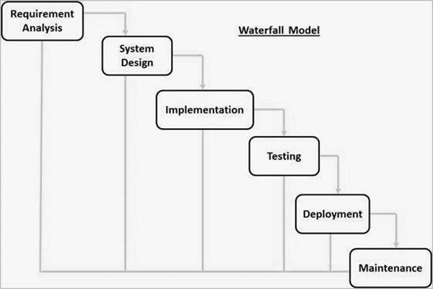

The sequential phases in Waterfall model are –
- Requirement Gathering and analysis − All possible requirements of the system to be developed are captured in this phase and documented in a requirement specification document.
- System Design − The requirement specifications from first phase are studied in this phase and the system design is prepared. This system design helps in specifying hardware and system requirements and helps in defining the overall system architecture.
- Implementation − With inputs from the system design, the system is first developed in small programs called units, which are integrated in the next phase. Each unit is developed and tested for its functionality, which is referred to as Unit Testing.
- Integration and Testing − All the units developed in the implementation phase are integrated into a system after testing of each unit. Post integration the entire system is tested for any faults and failures.
- Deployment of system − Once the functional and non-functional testing is done; the product is deployed in the customer environment or released into the market.
- Maintenance − There are some issues which come up in the client environment. To fix those issues, patches are released. Also to enhance the product some better versions are released. Maintenance is done to deliver these changes in the customer environment.

2.3 Flow of System
The system flow diagram is one of the graphical representations of the flow of data in a system in software engineering. The diagram consists of several steps that identify where the input is coming to the system and output going out of the system. With the help of the diagram, it is possible to control the event decisions of the system and how data is flowing to the system. Therefore, the system flow diagram is basically a visual representation of data flow, excluding the minor parts and including the major parts of the system in a sequential manner.
It is just like a data flow diagram that includes all the major steps of the flow of data in a system in a systematic and sequential manner and it is required because of its varieties of uses.

- It provides a visual representation of data that non-IT people get benefitted from its understanding part without requiring any special technical skills and it is very easier to show the loops and branches in a diagrammatic way and the conditions of the branches so that it is easily comprehensible for the user than using complex algorithms or pseudo-codes.
- We require a system flow diagram to detect the flaws of a system and to find the solution and then execute the solution in very easy and sequential steps that are major and excluding the minor ones that are less necessary.
- A system flow diagram is also required for large-scale industries that helps in visualizing all the major problems of the system and how to find effective solutions from that. The diagram also helps in understanding the flow of a process in a sequential manner, where the solution is going based on conditions and find the bottlenecks from it.
- We need a system flow diagram for quick communication among programmers, helping in the analysis of all valid inputs into the system, provides efficient coding to denote where and what data is using up for the system, and helps in debugging the
data that can cause potential damage to the system.
28

It is basically designed in the following ways for the programmer as well as the user can easily understand the problems and find out the potential outcomes from it:

- The diagram or the entire process starts with an oval-shaped symbol that depicts the beginning of the process or the starting point.
- The starting point is labelled as Start and labelling of other parts is also done in such a way that it means something for the process and depicts that which is doing what for the system.
- For the next step, the oval-shaped symbol is followed by drawing a rectangle, and labelling is done on the basis of that. Each and every step has its own representation and is used according to it.
- All the data inputs and output of the system are denoted by using a parallelogram and labelling is done.
- Arrows are used for connection between steps, to show the direction of flow of the process. The arrows are necessary to show the direction in which data is flowing and it is for a physical representation of data.
- Diamond symbols are used to represent the branching decisions or the condition in which a previous step depends upon. The next step of the process depends on the decision or the branching factor that is followed from the previous step.
- Rectangular symbols are drawn on the basis of the steps that are followed by decision points, labelling is doing according to that and also arrows are used to provide the way in which data is flowing and what are the steps followed by the next step.
- Labelling of flows of the diagram is necessary for correct representation and arrows to help in making decisions and to provide what solutions will be followed after that.
- Finally, an oval-shaped or rounded rectangle is used that is labelled as End that depicts the last step or the end of the whole process.


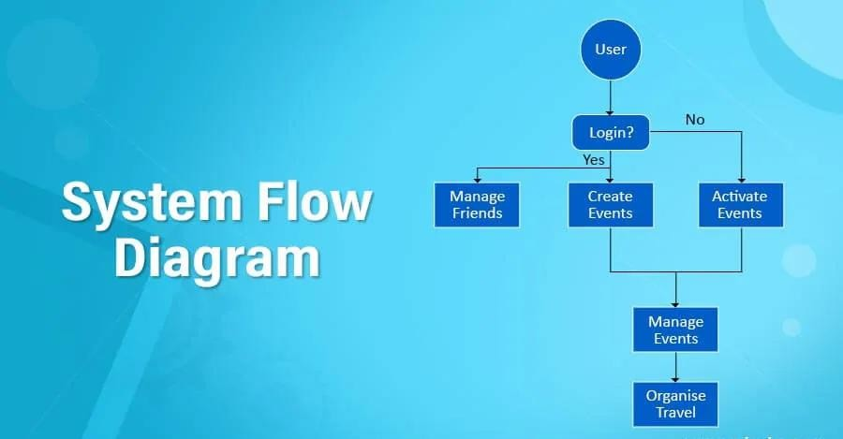
Activity diagrams are graphical representations of workflows of stepwise activities and actions with support for choice, iteration, and concurrency. In the Unified Modelling Language, activity diagrams are intended to model both computational and organizational processes (i.e., workflows), as well as the data flows intersecting with the related activities. Although activity diagrams primarily show the overall flow of control, they can also include elements showing the flow of data between activities through one or more data stores Activity diagrams can be regarded as a form of a structured flowchart combined with a traditional data flow diagram. Typical flowchart techniques lack constructs for expressing concurrency. However, the join and split symbols in activity diagrams only resolve this for simple cases; the meaning of the model is not clear when they are arbitrarily combined with decisions or loops. While in UML 1.x, activity diagrams were a specialized form of state diagrams, in UML 2.x, the activity diagrams were re-formalized to be based on Petri net-like semantics, increasing the scope of situations that can be modelled using activity diagrams. These changes cause many UML
1.x activity diagrams to be interpreted differently in UML 2.x.

UML activity diagrams in version 2.x can be used in various domains, e.g., in design ofϖ embedded systems. It is possible to verify such a specification using model checking technique.

3.4. System Design

Module diagrams are used to show the allocation of classes and objects to modules in the physical design of a system, that is module diagrams indicate the partitioning of the system architecture. Through these diagrams it is possible to understand the general physicalϖ architecture of a system.

The two essential elements of a module diagram are modules and theirϖ dependencies. The informal convention is to collect related modules in directoryϖ structures. The notion of subsystem is introduced for such a reason.

Subsystems partition the physical model of the system; they are aggregates containing other modules and other subsystems. A subsystem can have dependencies upon other subsystems or modules, andϖ a module can have dependencies upon a subsystem. The same notation is used for subsystems dependencies.

In this phase, a logical system is built which fulfils the given requirements. Design
phase of software development deals with transforming the client’s requirements into a logically working system. Normally, design is performed in the following in the following two steps: -

Primary Design Phase:
In this phase, the system is designed at block level. The blocks are created on the basis of analysis done in the problem identification phase. Different blocks are created for different functions emphasis is put on minimising the information flow between Thus, all activities which require more interaction are kept in one block.

Secondary Design Phase:
In the secondary phase the design of every block is performed.

The general tasks involved in the design process are the following;

- Design various blocks for overall system processes.
- Design smaller, compact and workable modules in each block.
- Design various database structures.
- Specify details of programs to achieve desired functionality.
- Design the form of inputs, and outputs of the system.
- Perform documentation of the design.
- System reviews.

User Interface Design: -

User Interface Design is concerned with the dialogue between a user and the computer. It is concerned with everything from starting or logging into the system to the eventually presentation of desired inputs and outputs. The overall flow of screens and messages is called a dialogue.

User Interface (UI) Design focuses on anticipating what users might need to do and ensuring that the interface has elements that are easy to access, understand, and use to facilitate those actions. UI brings together concepts from interaction design, visual design, and information architecture.

The following step are various guidelines for User Interface Design: -

- The system user should always be aware of what to do next.

- The screen should be formatted so that various types of information, instructions and messages always appear in the same general display area.

- Message, instructions, or information should be displayed long enough to allow he system user to read them.

- Use display attributes sparingly.

- Default values for fields and answers to be entered by the user should be specified.

- A user should not be allowed to proceed without correcting an error.

- The system user should never get an operating system message or fatal error.

Chapter 4:

Testing

TESTING APPROACH

Software Testing is evaluation of the software against requirements gathered from users and system specifications. Testing is conducted at the phase level in software development life cycle or at module level in program code. Software testing comprises of Validation and Verification.

White Box Testing: -

White box testing is a testing technique, that examines the program structure and derives test data from the program logic/code. The other names of glass box testing are clear box testing, open box testing, logic driven testing or path driven testing or structural testing.

In this technique, the close examination of the logical parts through the software are tested by cases that exercises species sets of condition or loops, all logical parts of the software checked once error that can be corrected using this technique are typographical errors, logical expressions which should be executed once may be getting executed more than once and error resulting by using wrong controls and loops.

When the box testing tests all the independent part within a module a logical decision on their true and the false side are exercised, all loops and bounds within their operational bounds were exercised and internal data structure to ensure their validity were exercised once.

White Box Testing Techniques:

- Statement Coverage - This technique is aimed at exercising all programming statements with minimal tests.
- Branch Coverage - This technique is running a series of tests to ensure that all branches are tested at least once.
- Path Coverage - This technique corresponds to testing all possible paths which means that each statement and branch is covered.


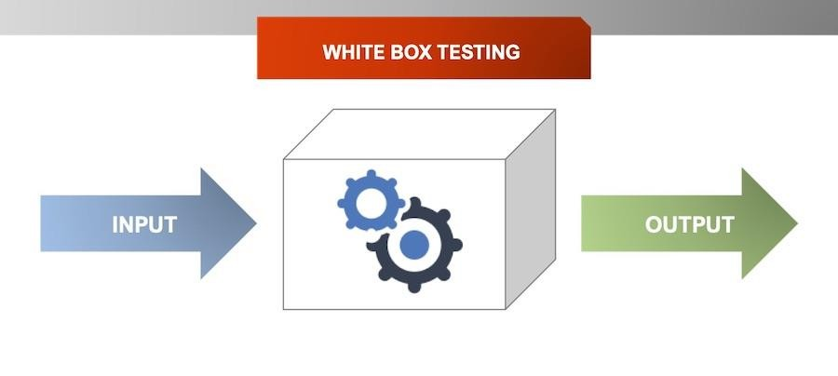
Black Box Testing: -

Black box testing is a technique of software testing which examines the functionality of software without peering into its internal structure or coding. The primary source of black box testing is a specification of requirements that is stated by the customer.

In this method, tester selects a function and gives input value to examine its functionality, and checks whether the function is giving expected output or not. If the function produces correct output, then it is passed in testing, otherwise failed.

The test team reports the result to the development team and then tests the next function. After completing testing of all functions if there are severe problems, then it is given back to the development team for correction.
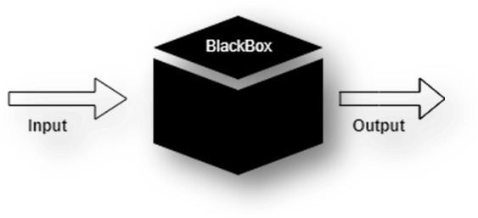

Generic steps of black box testing

- The black box test is based on the specification of requirements, so it is examined in the beginning.
- In the second step, the tester creates a positive test scenario and an adverse test scenario by selecting valid and invalid input values to check that the software is processing them correctly or incorrectly.
- In the third step, the tester develops various test cases such as decision table, all pairs test, equivalent division, error estimation, cause-effect graph, etc.
- The fourth phase includes the execution of all test cases.
- In the fifth step, the tester compares the expected output against the actual output.
- In the sixth and final step, if there is any flaw in the software, then it is cured and tested again.

Generic steps of black box testing

- The black box test is based on the specification of requirements, so it is examined in the beginning.
- In the second step, the tester creates a positive test scenario and an adverse test scenario by selecting valid and invalid input values to check that the software is processing them correctly or incorrectly.
- In the third step, the tester develops various test cases such as decision table, all pairs test, equivalent division, error estimation, cause-effect graph, etc.
- The fourth phase includes the execution of all test cases.
- In the fifth step, the tester compares the expected output against the actual output.
- In the sixth and final step, if there is any flaw in the software, then it is cured and tested again.

Alpha Testing: -

Alpha Testing is a type of software testing performed to identify bugs before releasing the product to real users or to the public. Alpha Testing is one of the user acceptance testings. This is referred to as alpha testing only because it is done early on, near the end of the development of the software. Alpha testing is commonly performed by homestead software engineers or quality assurance staff. It is the last testing stage before the software is released into the real world.

Objective of Alpha Testing:

- The objective of alpha testing is to refine the software product by finding the bugs that were not discovered during the previous tests.
- The objective of alpha testing is to refine the software product by fixing the bugs that were not discovered during the previous tests.
- The objective of alpha testing is to involve customers deep into the process of development.
- The objective of alpha testing is to give better insight into the software’s reliability at the early stages of development.

Alpha Testing Process:

- Review the design specification and functional requirements.
- Develop comprehensive test cases and test plans.
- Execute test plan
- Log defects

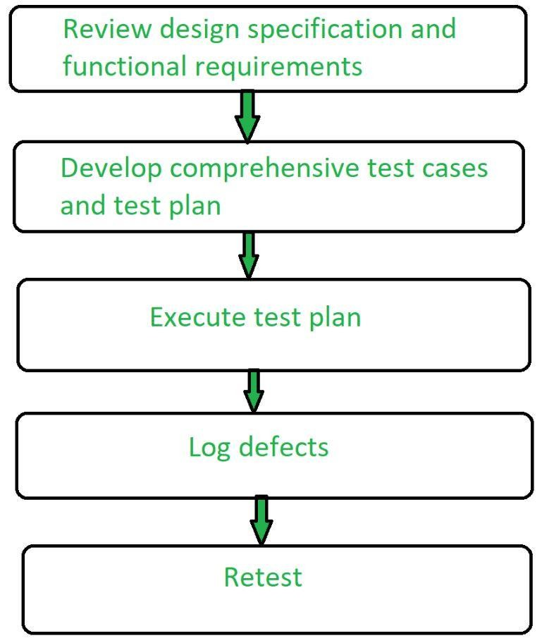

Phases of Alpha Testing:

There are two phases in alpha testing:
1st Phase:
The first phase of testing is done by in-house developers or software engineers. They either use hardware-aided debuggers or debugger software. The aim is to catch bugs quickly.
Usually while alpha testing, a tester comes across to lots of bugs, crashes, missing features, and docs.

2nd Phase:
The second phase of alpha testing is done by software quality assurance staff for additional testing in an environment. It includes a black box as well as white box testing.

Beta Testing: -
Beta Testing is performed by real users of the software application in a real environment. Beta testing is one of the types of User Acceptance Testing. A Beta version of the software, whose feedback is needed, is released to a limited number of end-users of the product to obtain feedback on the product quality. Beta testing helps in minimization of product failure risks and it provides increased quality of the product through customer validation. It is the last test before shipping a product to the customers.

Characteristics of Beta Testing:

- Beta Testing is performed by clients or users who are not employees of the company.
- Reliability, security, and robustness are checked during beta testing.
- Beta Testing commonly uses black-box testing.
- Beta testing is carried out in the user’s location.
- Beta testing doesn’t require a lab or testing environment.

Types of Beta Testing:

There are different types of beta testing:
- Traditional Beta testing: Product is distributed to the target market and related data is gathered in all aspects. This data can be used for Product improvement.
- Public Beta Testing: Product is released publicly to the world through online channels and data can be collected from anyone. Based on feedback, product improvements can be done. For example, Microsoft conducted the largest of all Beta Tests for its operating system Windows 8 before officially releasing it.
- Technical Beta Testing: Product is released to a group of employees of an organization and collects feedback/data from the employees of the organization.
- Focused Beta Testing: Software product is released to the market for collecting feedback on specific features of the program. For example, important functionality of the software.
- Post-release Beta Testing: Software product is released to the market and data is collected to make improvements for the future release of the product.

Unit Testing: -

Unit Testing is a software testing technique by means of which individual units of software
i.e. group of computer program modules, usage procedures, and operating procedures are tested to determine whether they are suitable for use or not.

It is a testing method using which every independent module is tested to determine if there is an issue by the developer himself. It is correlated with the functional correctness of the independent modules. Unit Testing is defined as a type of software testing where individual components of a software are tested.

Unit Testing of the software product is carried out during the development of an application. An individual component may be either an individual function or a procedure. Unit Testing is typically performed by the developer.

In SDLC or V Model, Unit testing is the first level of testing done before integration testing. Unit testing is such a type of testing technique that is usually performed by developers. Although due to the reluctance of developers to test, quality assurance engineers also do unit testing.

Objective of Unit Testing:

The objective of Unit Testing is:
- To isolate a section of code.

- To verify the correctness of the code.

- To test every function and procedure.

- To fix bugs early in the development cycle and to save costs.

- To help the developers to understand the code base and enable them to make changes quickly.

- To help with code reuse.

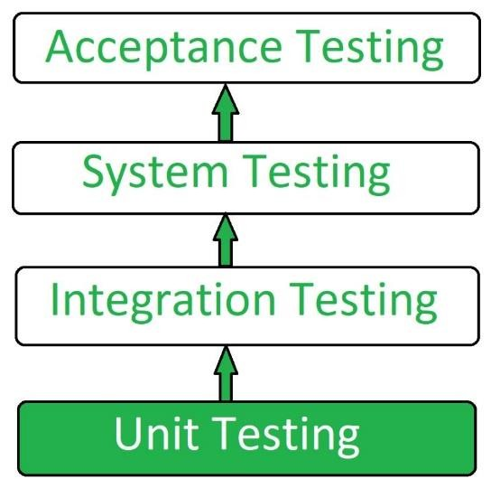

Types of Unit Testing:

There are 2 types of Unit Testing: Manual, and Automated. Integration Testing: -
Integration testing is the process of testing the interface between two software units or modules. It focuses on determining the correctness of the interface. The purpose of integration testing is to expose faults in the interaction between integrated units. Once all the modules have been unit tested, integration testing is performed.
Integration testing can be done by picking module by module.

Integration test approaches – There are four types of integration testing approaches. Those approaches are the following:

Big-Bang Integration Testing –
It is the simplest integration testing approach, where all the modules are combined and the functionality is verified after the completion of individual module testing. In simple words, all the modules of the system are simply put together and tested. This approach is practicable only for very small systems. If an error is found during the integration testing, it is very difficult to localize the error as the error may potentially belong to any of the modules being integrated. So, debugging errors reported during big bang integration testing is very expensive to fix.

- Bottom-Up Integration Testing – In bottom-up testing, each module at lower levels is tested with higher modules until all modules are tested. The primary purpose of this integration testing is that each subsystem tests the interfaces among various

modules making up the subsystem. This integration testing uses test drivers to drive and pass appropriate data to the lower level modules.

- Top-Down Integration Testing – Top-down integration testing technique is used in order to simulate the behaviour of the lower-level modules that are not yet integrated. In this integration testing, testing takes place from top to bottom. First, high-level modules are tested and then low-level modules and finally integrating the low-level modules to a high level to ensure the system is working as intended.

- Mixed Integration Testing – A mixed integration testing is also called sandwiched integration testing. A mixed integration testing follows a combination of top down and bottom-up testing approaches. In top-down approach, testing can start only after the top-level module have been coded and unit tested. In bottom-up approach, testing can start only after the bottom level modules are ready. This sandwich or mixed approach overcomes this shortcoming of the top-down and bottom-up approaches. It is also called the hybrid integration testing. also, stubs and drivers are used in mixed integration testing.

Validation Testing: -
The process of evaluating software during the development process or at the end of the development process to determine whether it satisfies specified business requirements.
Validation Testing ensures that the product actually meets the client's needs. It can also be defined as to demonstrate that the product fulfils its intended use when deployed on appropriate environment.
It answers to the question, are we building the right product?

Validation Testing - Workflow:

Validation testing can be best demonstrated using V-Model. The Software/product under test is evaluated during this type of testing.

System Testing: -System Testing is a type of System Testing that is performed on a complete integrated system to evaluate the compliance of the system with the corresponding requirements. In system testing, integration testing passed components are taken as input. The goal of integration testing is to detect any irregularity between the units that are integrated together. System testing detects defects within both the integrated units and the whole system. The result of system testing is the observed behaviour of a component or a system when it is tested. System Testing is carried out on the whole system in the context of either system requirement specifications or functional requirement specifications or in the context of both. System testing tests the design and behaviour of the system and also the expectations of the customer. It is performed to test the system beyond the bounds mentioned in the (SRS) Software Requirements Specification. System Testing is basically performed by a testing team that is independent of the development team that helps to test the quality of the system impartial. It has both functional and non-functional testing. System Testing is a
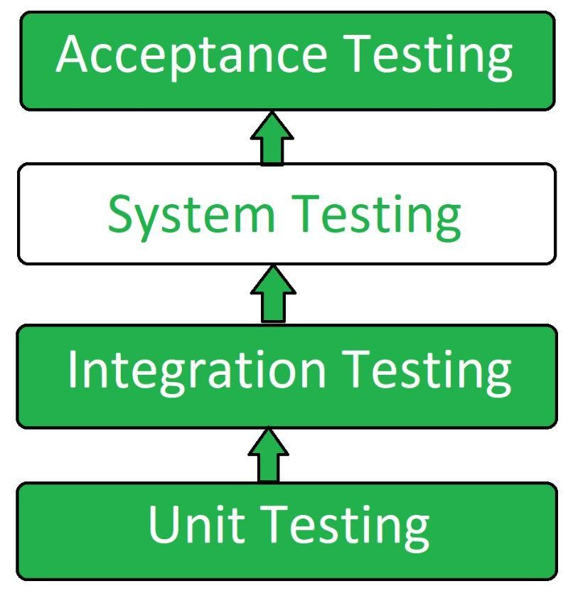
black-box testing. System Testing is performed after the integration testing and before the acceptance testing.

System Testing Process:
System Testing is performed in the following steps:
- Test Environment Setup: Create testing environment for the better quality testing.
- Create Test Case: Generate test case for the testing process.
- Create Test Data: Generate the data that is to be tested.
- Execute Test Case: After the generation of the test case and the test data, test cases are executed.
- Defect Reporting: Defects in the system are detected.
- Regression Testing: It is carried out to test the side effects of the testing process.
- Log Defects: Defects are fixed in this step.


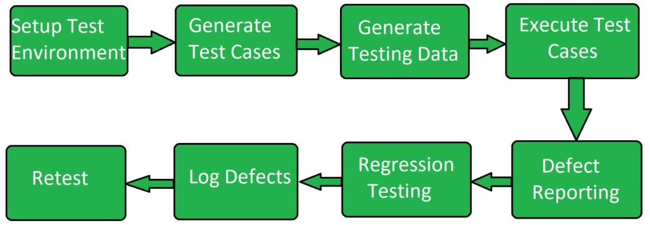
- Retest: If the test is not successful then again test is performed.

Types of System Testing:
- Performance Testing: Performance Testing is a type of software testing that is carried out to test the speed, scalability, stability and reliability of the software product or application.
- Load Testing: Load Testing is a type of software Testing which is carried out to determine the behaviour of a system or software product under extreme load.
- Stress Testing: Stress Testing is a type of software testing performed to check the robustness of the system under the varying loads.
- Scalability Testing: Scalability Testing is a type of software testing which is carried out to check the performance of a software application or system in terms of its capability to scale up or scale down the number of user request load.
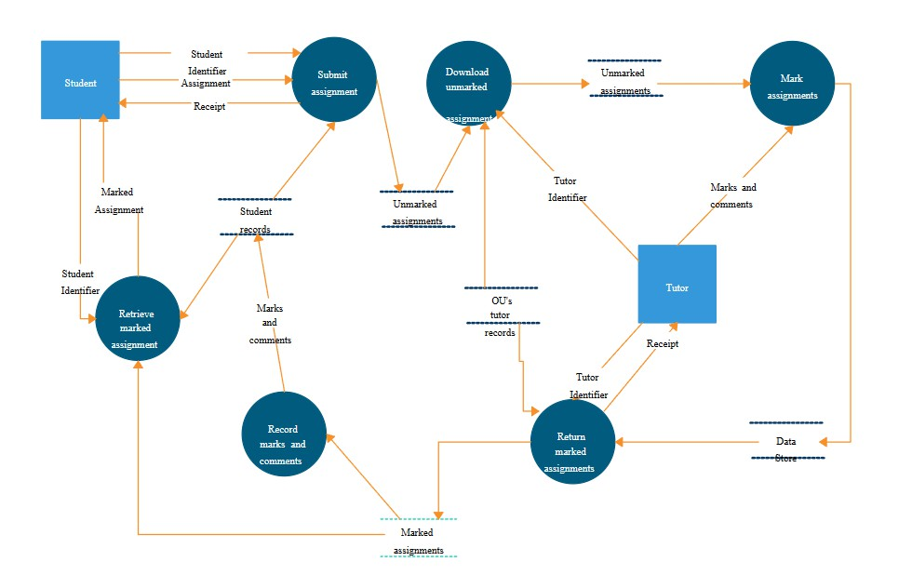
DFD DIAGRAM:

ER DIAGRAM

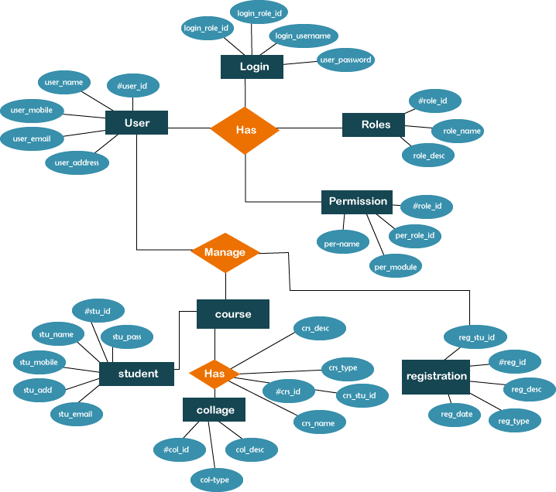

BLOCK DIAGRAM

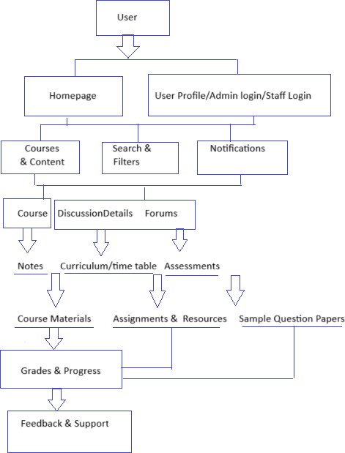

CLASS DIAGRAM

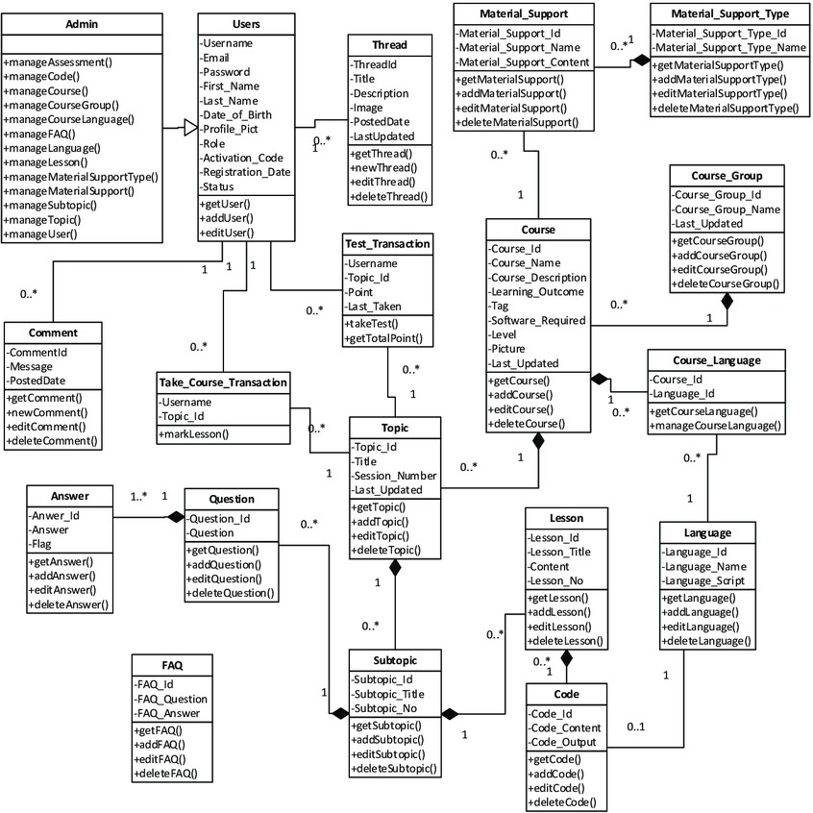

USE CASE DIAGRAM

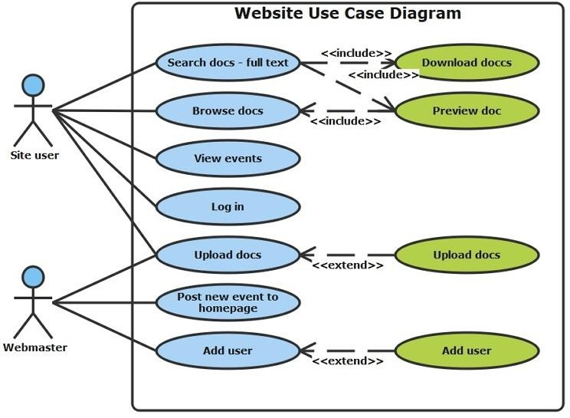

\

CHAPTER 5

  - APPENDICES
PROJECT STRUCTURE:
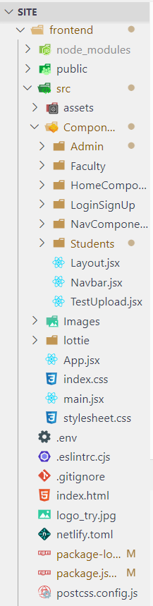
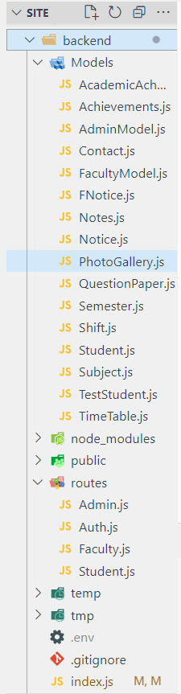

CODE:

import React from 'react' import "./Custom.css";
import ITLogo from '../../Images/logo_try.jpg' import GPMLogo from '../../Images/GPM-LOGO.png' import home_gif from '../../Images/home_4.gif' import rightImg from '../../Images/rightImgBg.png' function Top() {
return (
<>
<div className='w-[100%] h-screen max-h-screen md:pt-5 bg-blue-50' >
<div className='px-[10%]'>
{/* <div className='absolute top-0 left-0 w-[100%] h-screen z-0' style={{ background: 'rgba(0,0,0,0.7)' }}></div> */}
<div className='flex md:flex-row-reverse flex-col-reverse justify-center items-center z-10 max- md:gap-y-16 max-md:pt-20' >
<div className='h-[80%] w-[80%] '>

<img src={rightImg} alt="" className='h-[100%] w-[100%] ' />
</div>
<div className='flex flex-col text-center justify-center items-center w-[100%] h-[100%]'>
<div className='flex flex-row gap-2 '>
<img src={GPMLogo} alt="logo-GPM" className='h-[80px] w-[80px] rounded-[50%]' />
{/* <img src={ITLogo} alt="logo-IT" className='md:hidden rounded-[50%] w-[65px] h- [65px] mt-0 object-cover ' /> */}
</div>
<div>
<h1 className='text-2xl font-semibold text-[#0099ff]'>Government Polytechnic Mumbai</h1>
<h1 className='md:text-3xl text-3xl font-bold text-slate-800'>Department Of Information Technology</h1>

<h4 className='text-gray-700 text-xl'>(An autonomous Institute of Government of Maharashtra)</h4>
</div>
</div>
</div>
</div>
<div>

<svg xmlns="http://www.w3.org/2000/svg" viewBox="0 0 1440 320">
<path fill="#0099ff" fill-opacity="1" d="M0,32L30,37.3C60,43,120,53,180,90.7C240,128,300,192,360,192C420,192,480,128,540,106.7C6 00,85,660,107,720,128C780,149,840,171,900,192C960,213,1020,235,1080,234.7C1140,235,1200,21
3,1260,208C1320,203,1380,213,1410,218.7L1440,224L1440,320L1410,320C1380,320,1320,320,126
0,320C1200,320,1140,320,1080,320C1020,320,960,320,900,320C840,320,780,320,720,320C660,320
,600,320,540,320C480,320,420,320,360,320C300,320,240,320,180,320C120,320,60,320,30,320L0,32
0Z"></path>
</svg>

</div>
</div>
</>
)
}

export default Top

Routes:
import React from "react"
import { BrowserRouter, Route, Routes } from 'react-router-dom' import Home from "./Components/HomeComponents/Home"
import FacultyDetailes from "./Components/NavComponents/FacultyDetailes" import Curriculum from "./Components/NavComponents/Curriculum"
import Contact from "./Components/NavComponents/Contact" import Layout from "./Components/Layout"

import Login from "./Components/LoginSignUp/Login" import AddFaculty from "./Components/Admin/AddFaculty" import AddUser from './Components/Admin/AddUser' import Dashboard from "./Components/Admin/dashboard" import Sidebar from "./Components/Admin/Sidebar" import AddNotes from "./Components/Admin/AddNotes" function App() {

return (
<>
<BrowserRouter >
{/* <Navbar /> */}
<Routes>
<Route path='/' element={<Layout />} >
<Route exact path="/" element={<Home />} ></Route>
<Route exact path='/FacultyDetailes' element={<FacultyDetailes />}></Route>
<Route exact path='/Curriculum' element={<Curriculum />}></Route>
<Route exact path='/Contact' element={<Contact />}></Route>
<Route exact path='/Login' element={<Login />}></Route>
</Route>
<Route path='/Admin' element={<Sidebar />}>
<Route exact path='/Admin/Dashboard' element={<Dashboard/>}></Route>
<Route exact path='/Admin/AddStudent' element={<AddUser />}></Route>
<Route exact path='/Admin/ManageStudent' element={<AddUser />}></Route>
<Route exact path='/Admin/AddFaculty' element={<AddFaculty />}></Route>
<Route exact path='/Admin/ManageFaculty' element={<AddFaculty />}></Route>
<Route exact path='/Admin/AddNotes' element={<AddNotes />}></Route>
<Route exact path='/Admin/ManageNotes' element={<AddFaculty />}></Route>
<Route exact path='/Admin/AddQP' element={<AddFaculty />}></Route>
<Route exact path='/Admin/ManageQP' element={<AddFaculty />}></Route>
<Route exact path='/Admin/AddTimeTable' element={<AddFaculty />}></Route>

<Route exact path='/Admin/ManageTimeTable' element={<AddFaculty />}></Route>
<Route exact path='/Admin/AddNotice' element={<AddFaculty />}></Route>
<Route exact path='/Admin/ManageNotice' element={<AddFaculty />}></Route>
</Route>
</Routes>
</BrowserRouter>
</>
)
}
export default App

Backend:
const express = require("express"); const app = express(); require("dotenv").config();
const cors = require("cors");
const mongoose = require("mongoose");
const fileUpload = require("express-fileupload"); const admin = require("./routes/Admin");
const student = require("./routes/Student"); const auth = require("./routes/Auth");
const faculty = require("./routes/Faculty"); const PORT = 3000;
const url = process.env.API; app.use(
cors({
origin: "https://information-technology.netlify.app", methods: ["POST", "GET", "DELETE", "PUT","HEAD","PATCH"],
credentials: true, optionSuccessStatus: 200,

})
);
app.use(express.json()); app.use(
fileUpload({ useTempFiles: true,
})
);

const options = { useNewUrlParser: true, useUnifiedTopology: true,
};
mongoose
.connect(url, options)
.then(() => {
console.log("Connected to MongoDB");
})
.catch((err) => {
console.error("Error connecting to MongoDB:", err);
});
app.use("/api/v1", admin); app.use("/api/v2", student); app.use("/api/v3", auth); app.use("/api/v4", faculty);

app.listen(PORT, () => {
console.log(`Server is running on port ${PORT}`);
});
Student Model:
const mongoose = require("mongoose");

const studentSchema = new mongoose.Schema({ name: {
type: String, required: true,
},
email: {
type: String, required: true,
},
EnrNo: { type:String, required:true
},
password: { type: String, required: true,
},
phone: {
type: Number, required:true
},
role: {
type: Number, default: 1,
},
semester: {
type: mongoose.Schema.Types.ObjectId, ref: "Semester",
required: true,
},
shift: {

type: mongoose.Schema.Types.ObjectId, ref: "Shift",
required: true,
},
createdAt: { type: Date,
default: Date.now,
},
});

const student = mongoose.model("student", studentSchema); module.exports = student;
DATABASE:
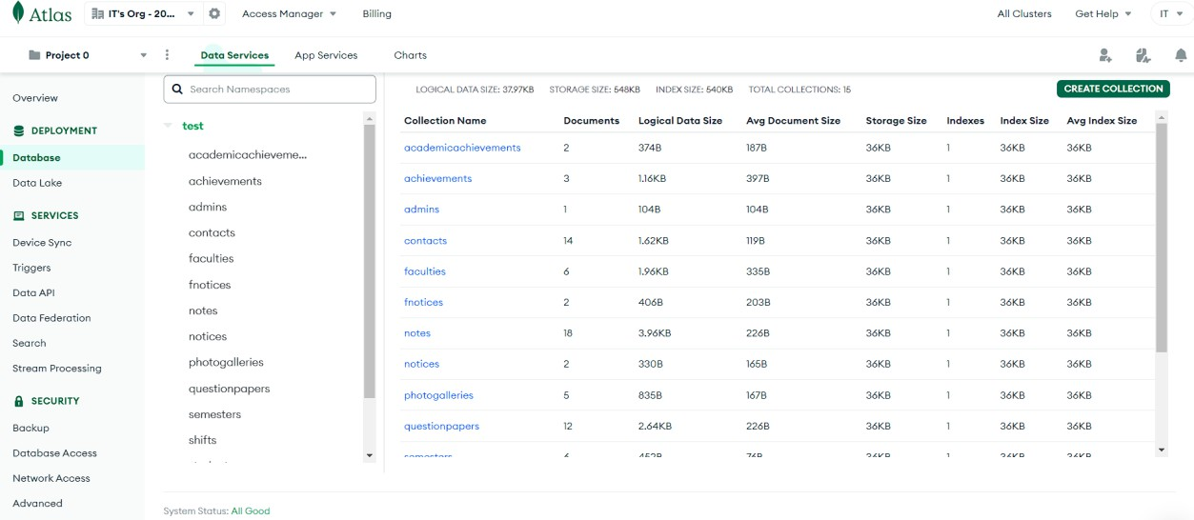
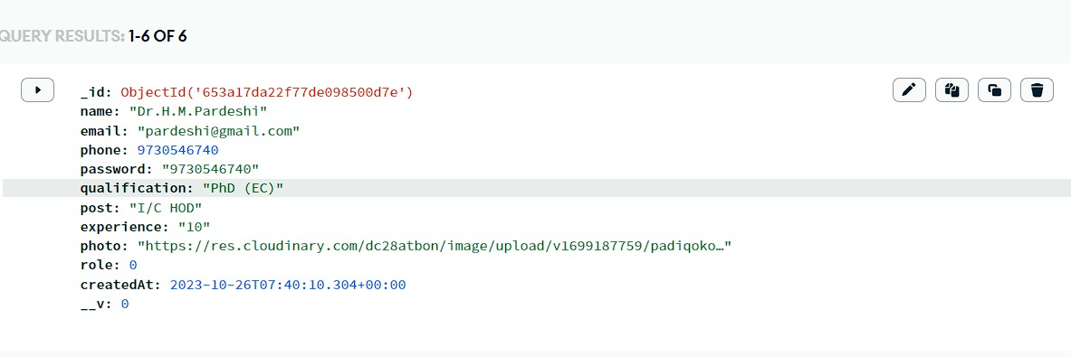

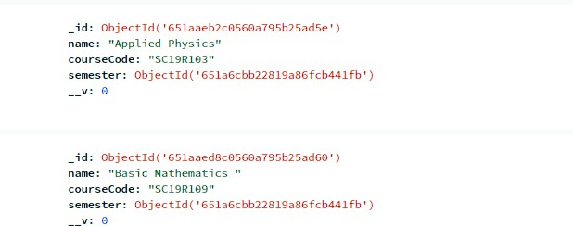

OUTPUT:

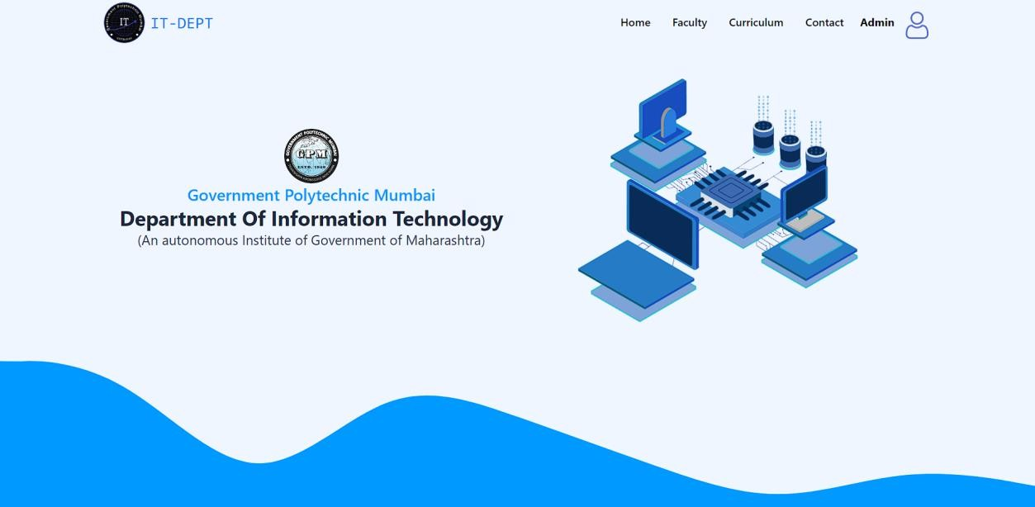

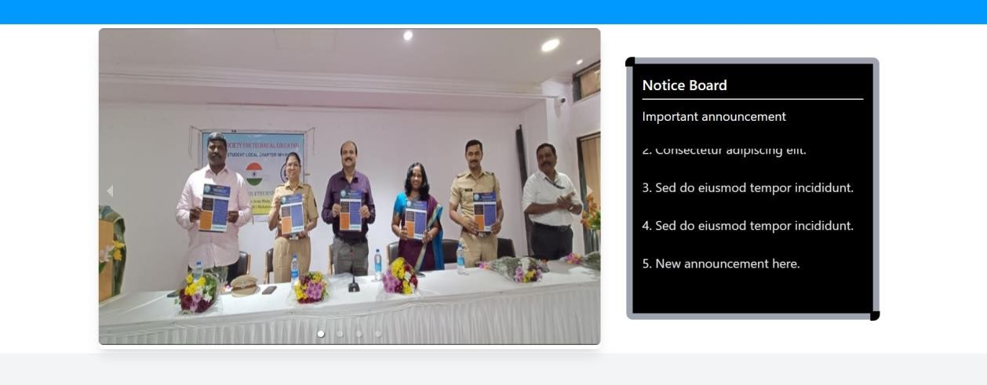
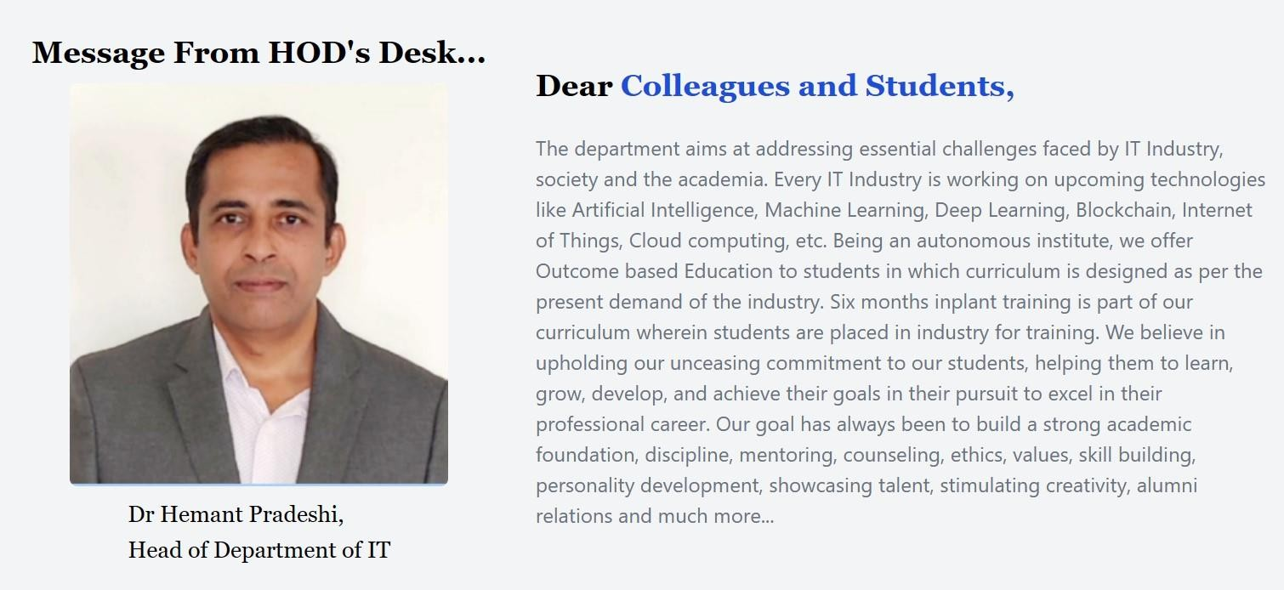
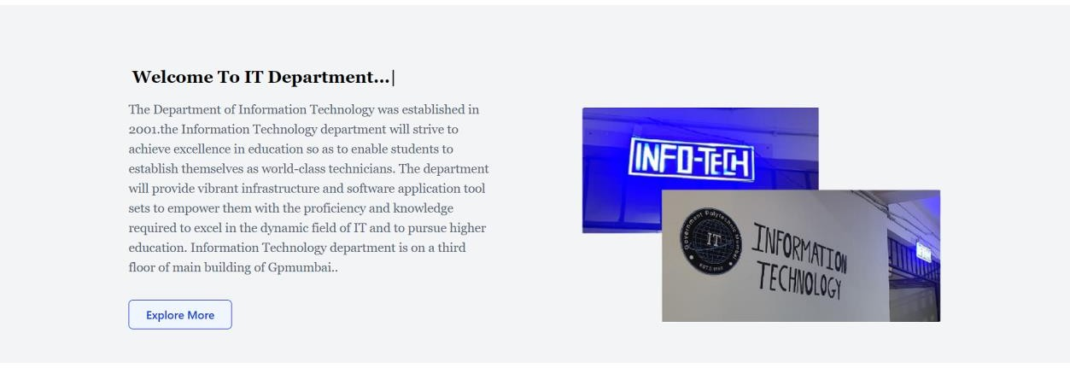

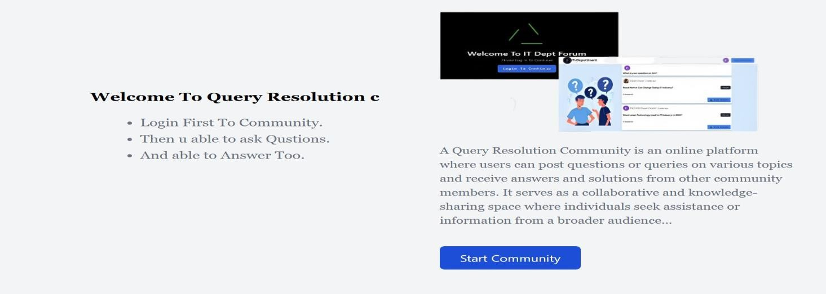
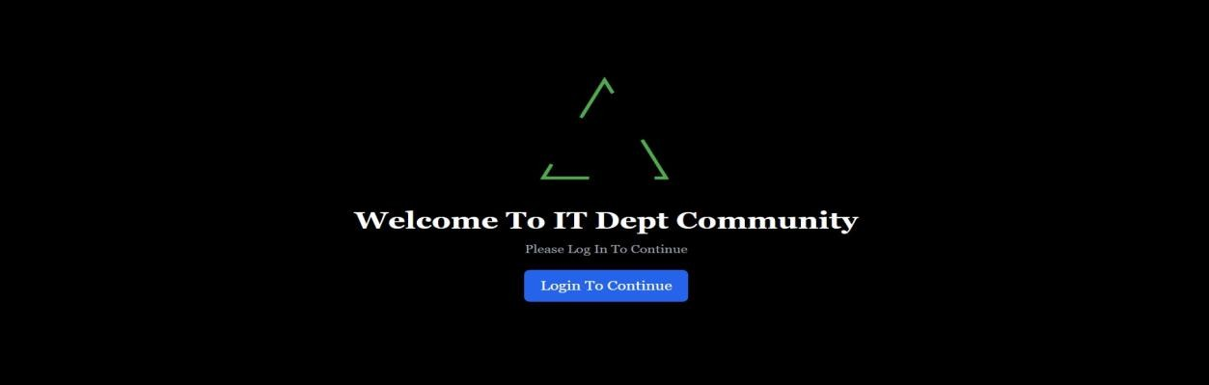
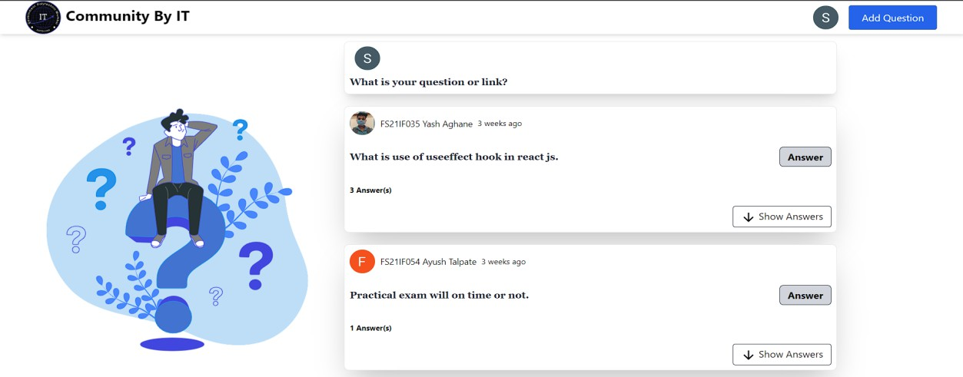

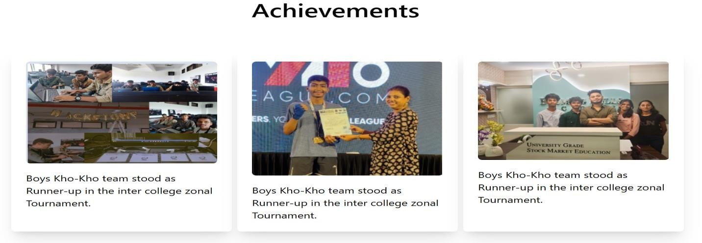

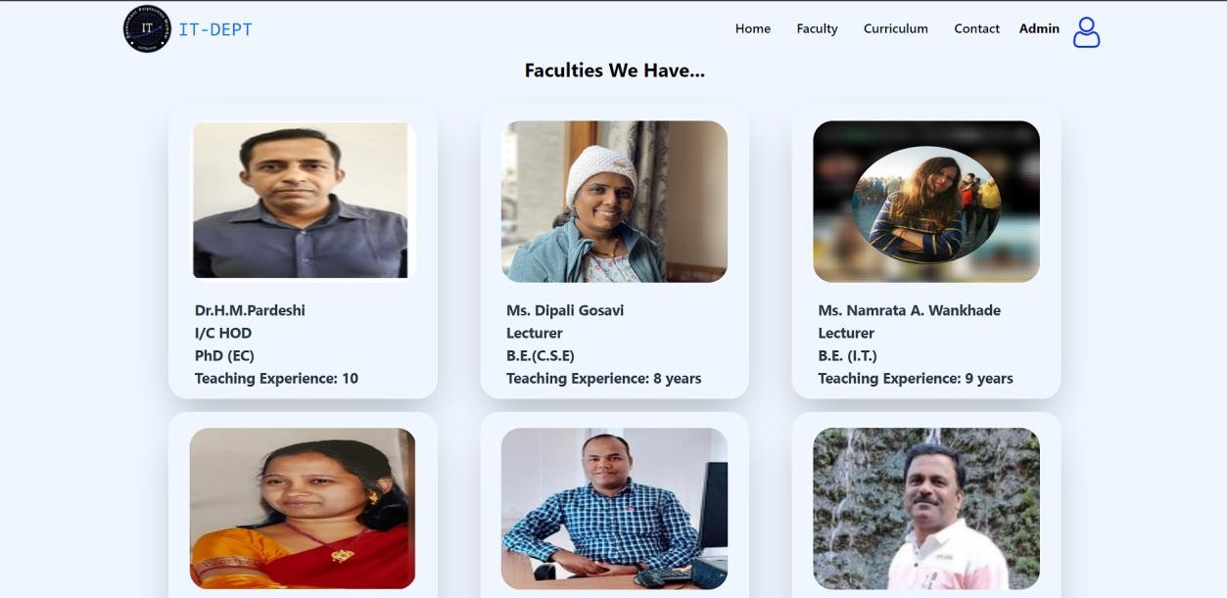
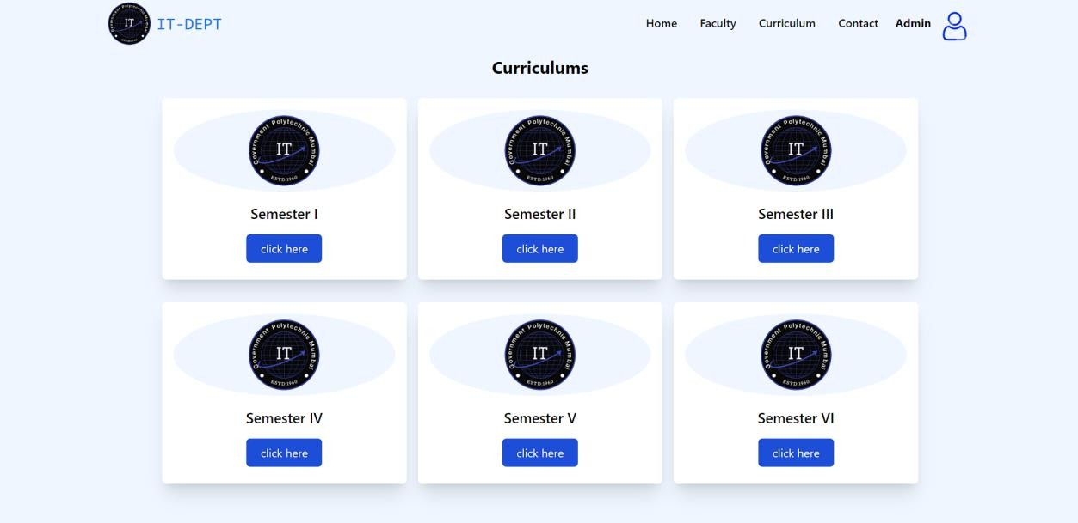

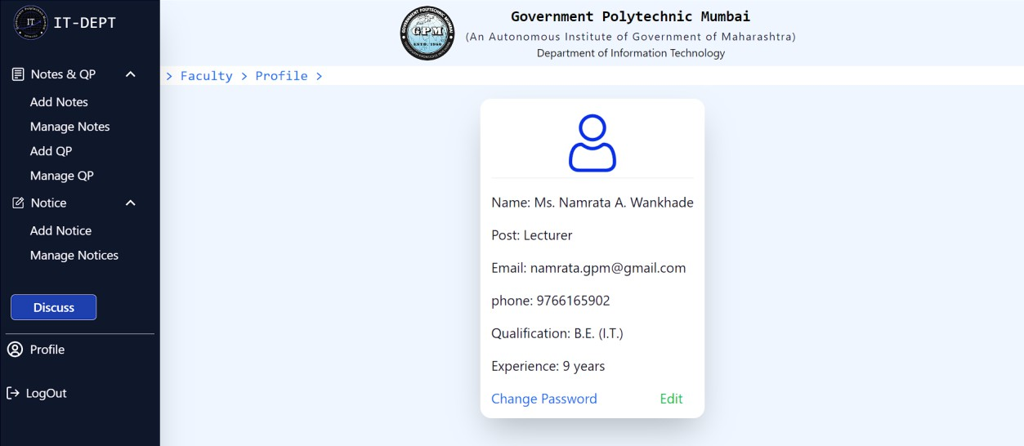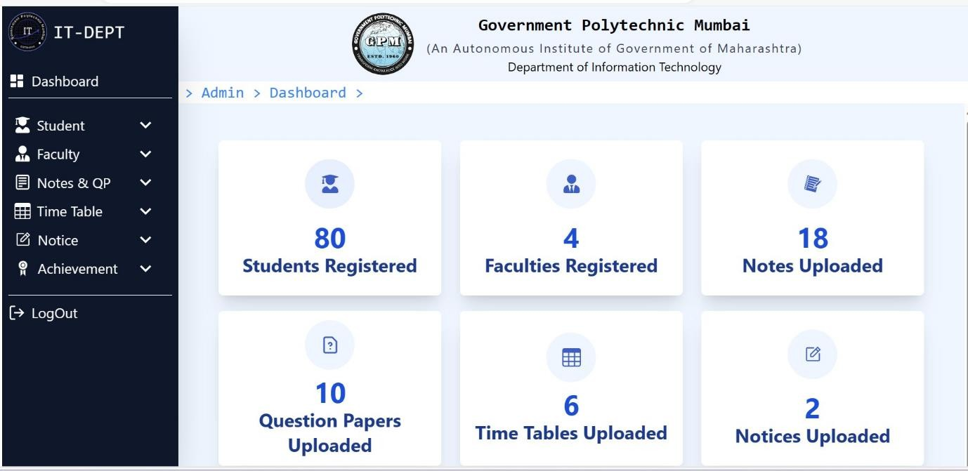
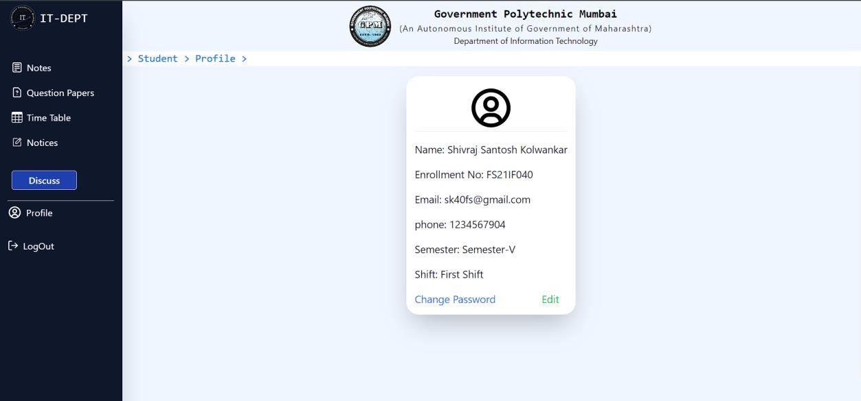

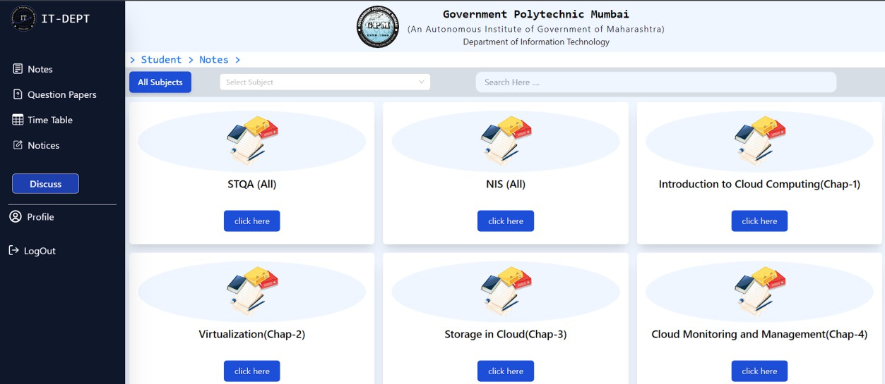

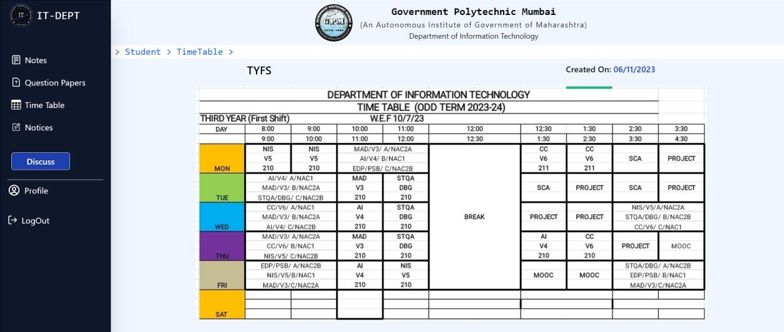

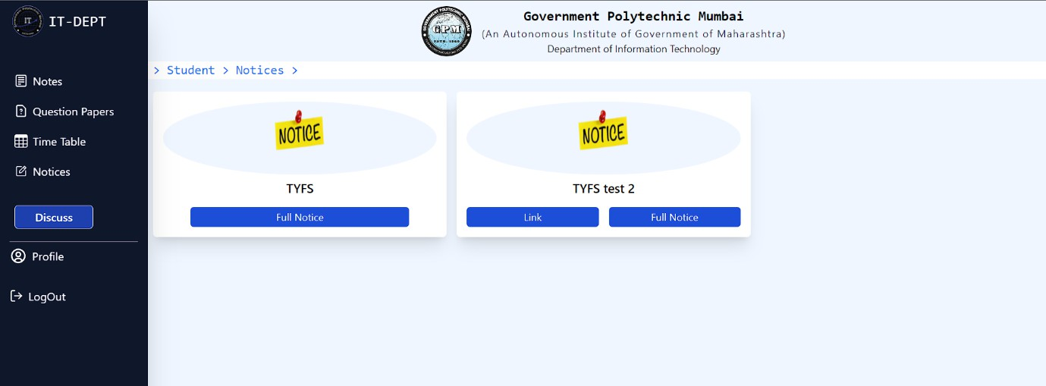

  - REFERENCES
Online references:

    - For storing: https://github.com/

    - For images/illustrations: https://undraw.co/ https://lexica.art/

    - For UI components: https://getwaves.io/

    - For diagrams: https://practice.geeksforgeeks.org/ https://www.javatpoint.com/ https://google.com/

    - For theoretical explanation: https://www.javatpoint.com/ https://practice.geeksforgeeks.org/ https://google.com/

    - Logical help and innovative ideas: https://www.upgrad.com/ https://tailwindcss.com/ https://react.dev/

  - FUTURE SCOPE
While we have achieved considerable success with the IT department college website, there are several avenues for future development and improvement:
Enhanced User Experience: Continuously gather user feedback and conduct usability testing to refine the website's design and functionality, ensuring an even better user experience.
Advanced Self-Service Tools: Develop and implement advanced self-service tools, including automated troubleshooting guides and AI-driven chatbots, to provide instant solutions to common IT issues.
Personalization: Implement personalization features that tailor content and recommendations based on individual user preferences and academic progress.
Integration: Explore opportunities for integrating with other college systems, such as the learning management system (LMS), to streamline data sharing and provide a seamless experience for students and faculty.
Analytics and Insights: Invest in robust analytics and reporting tools to gain insights into user behaviour, website performance, and the effectiveness of IT services.
Mobile App: Consider developing a dedicated mobile application for the IT department to offer on-the-go access to essential services and resources.
AI and Machine Learning: Leverage artificial intelligence and machine learning for predictive analytics, such as identifying potential IT issues before they occur.
Virtual Labs: Create virtual labs and interactive simulations for IT-related coursework, allowing students to gain practical experience online.
Cybersecurity Resources: Expand the website's cybersecurity resources and training modules to educate users about online security best practices.
Community Engagement: Foster a sense of community by introducing features like student IT clubs, IT-related challenges, and hackathons.
Multilingual Support: Consider offering multilingual support to accommodate a diverse student population.
Data Integration and Visualization: Explore opportunities to provide data visualization tools that help students and faculty make informed decisions about technology choices and resources.

5.3 CONCLUSION

The development and deployment of the IT department website for our college have undeniably ushered in a new era of efficiency and connectivity within our academic community. This web platform has effectively served as a central hub for all things IT- related, making information readily accessible to students, faculty, and staff. It has streamlined communication, empowered users with self-service tools, and provided valuable resources to support academic success. As we reflect on the journey thus far, it is evident that the website has already become an indispensable asset for our institution.

Moreover, the IT department website has catalysed improvements in IT service delivery. Users now have easy access to a comprehensive service catalog, enabling them to quickly find solutions to common IT issues. The website has fostered a culture of self-reliance, allowing students and faculty to troubleshoot problems independently, thereby reducing the workload on IT staff and improving response times for more complex issues. As we look ahead, we are excited about the future developments that will further elevate the website's capabilities, ultimately enhancing the overall academic experience for our college community.

In conclusion, the development and deployment of the IT department college website have brought about significant advantages for our educational institution. The website has successfully fulfilled its primary objectives of providing accessible information, facilitating communication, and enhancing the overall user experience for students, faculty, and staff.

